Engineering Question Sheet
工程问客单

Customer Code  (客户代号) |  | VPCBV-081  774-1 | Customer P/N  (客户型号) |  | PCB_EVK75123-MLX75024 V1.1
Factory P/N  (工厂型号) |  | Q18C-0103  S034879C8A0 | MI Prepare  (订单制作人) |  | QZY
Date  (日期) |  | 7/29/2026 | Phone Number  (电话号码)
Items | CONTENT OF EQ (问客的内客)
NO.1 Question  (工程问题1) | 如图1所示 客户提供的文档“EVK75123-MLX75024.EXTREP” 内顺序并非叠层顺序 我司将忽略它  Please fig1 and fig2, about the layer sort from top side to bottom side, we will follow fig2 to do. |  |  | Suggestions（我司建议）：  忽略它 按图2所示叠层制作  The layer sort follow fig2 to do
NO.1 Question  (工程问题1) |  |  |  | Cust reply(客户回复)：
NO.2 Question  (工程问题2) | 如图3所示，制作要求显示此板只有单面字符，但是实际gerber文件中有两面字符文件请确认！  Please see fig3, it indicates only top silk screen layer in this board, but two silk screen layers in gerber file. |  |  | Suggestions（我司建议）：  参考前版本 按单面字符制作  Follow only top silk screen layer to do
NO.2 Question  (工程问题2) |  |  |  | Cust reply(客户回复)：
NO.3Question  (工程问题3) | 附件为我司阻抗确认报表请确认是否OK？  Encloses is our impedance control list, and no impedance traces in layer 6  PS:L6层无差分阻抗 |  |  | Suggestions（我司建议）：  按附件阻抗报表制作  Follow it to produce
NO.3Question  (工程问题3) |  |  |  | Cust reply(客户回复)：
NO.4Question  (工程问题4) | 如图4所示 客户原设计焊盘间距太近 部分铜皮无法保留  Please see fig4, some pads are too closed to around copper. |  |  | Suggestions（我司建议）：  在不影响网络的情况下 允许删除此类似铜皮  We will shave the copper to keep safe spacing, and ensure internet connection is ok.
NO.4Question  (工程问题4) |  |  |  | Cust reply(客户回复)：
NO.5Question  (工程问题5) | 附件为我司生产稿 请确认！  Encloses is our checkplots. Please confirm. |  |  | Suggestions（我司建议）：  按附件生产稿制作  Follow it to produce
NO.5Question  (工程问题5) |  |  |  | Cust reply(客户回复)：
Fig.1
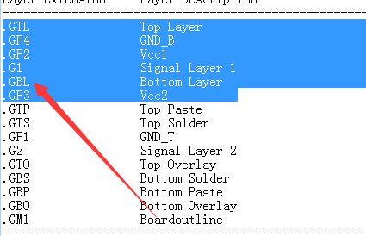
Fig.2
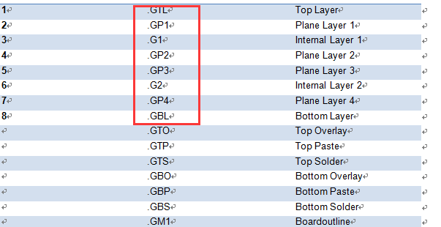
Fig.3
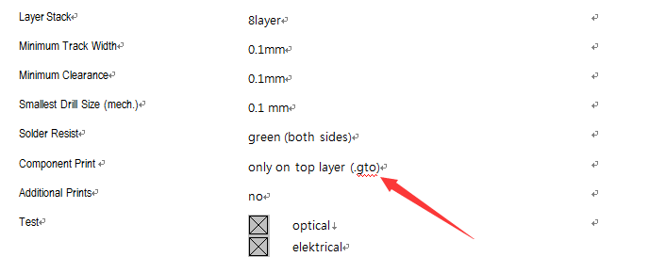
Fig.4
