Engineering Question Sheet
工程问客单

Customer Code  (客户代号) |  | VPCBV-081  774 | Customer P/N  (客户型号) |  | 850-4920 PCB_EVK75123-ML  X75024V1.0
Factory P/N  (工厂型号) |  | Q17C-0334  S024337C8A0 | MI Prepare  (订单制作人) |  | Km
Date  (日期) |  | 2017-4-19 | Phone Number  (电话号码)
Items | CONTENT OF EQ (问客的内客)
NO.1 Question  (工程问题1) | 图1和图2，两处叠层顺序中不一致我司不确定此板具体层顺序！  Please see fig1 and fig2, the stacking sequence is inconsistent |  |  | Suggestions（我司建议）：  - 建议按图1叠层顺序制作（按图1叠层才能满足贵司的阻抗要求）  We suggest to follow fig 1 to do, it can be meet the impedance requirement.
NO.1 Question  (工程问题1) |  |  |  | Cust reply(客户回复)：  Yes, fig2 is wrong
NO.2 Question  (工程问题2) | 图3，制作要求显示此板只有单面字符，但是实际gerber文件中有两面字符文件请确认！  Please see fig3, it indicated only top silk screen in this board, but there are two sides silk screen layer in gerber file. |  |  | Suggestions（我司建议）：  按单面字符制作  Follow only only top silk screen to produce
NO.2 Question  (工程问题2) |  |  |  | Cust reply(客户回复)：  Yes, only top silk screen
NO.3 Question  (工程问题3) | 附件阻抗确认函，请确认是否ok！ （.g2层中没有对应的阻抗线）  Enclosed is Impedance Confirmation Letter, and please kindly note no impedance trace in layer .g2 |  |  | Suggestions（我司建议）：  按附件阻抗确认函阻抗叠层制作(按图一叠层计算)  Follow our suggestion to do.
NO.3 Question  (工程问题3) |  |  |  | Cust reply(客户回复)：  OK
NO.4 Question  (工程问题4) | 附件生产文件请确认！  Enclosed is checkplots |  |  | Suggestions（我司建议）：  按附件生产文件制作！  Follow it to produce.
NO.4 Question  (工程问题4) |  |  |  | Cust reply(客户回复)：  Good to go

Fig1
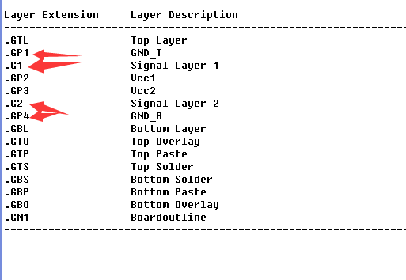
Fig2
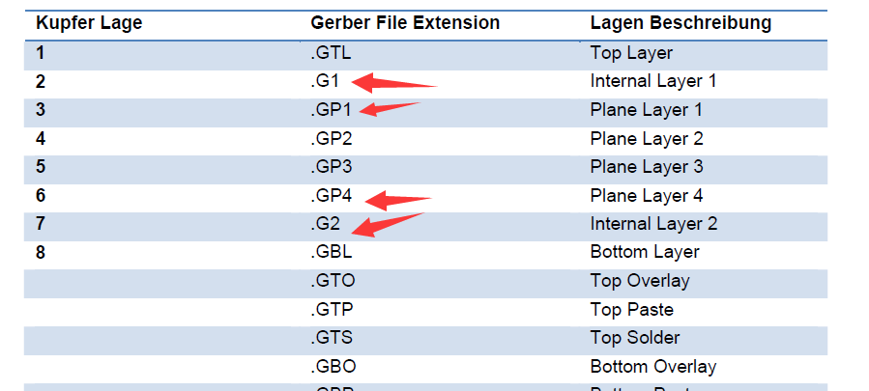

Fig3
